

**Mission 7:**

**Remix**

**Student Workbook**





**Make a list and check it twice!**

This assignment will let you be creative and come up with your own program for the   
CodeX to run.

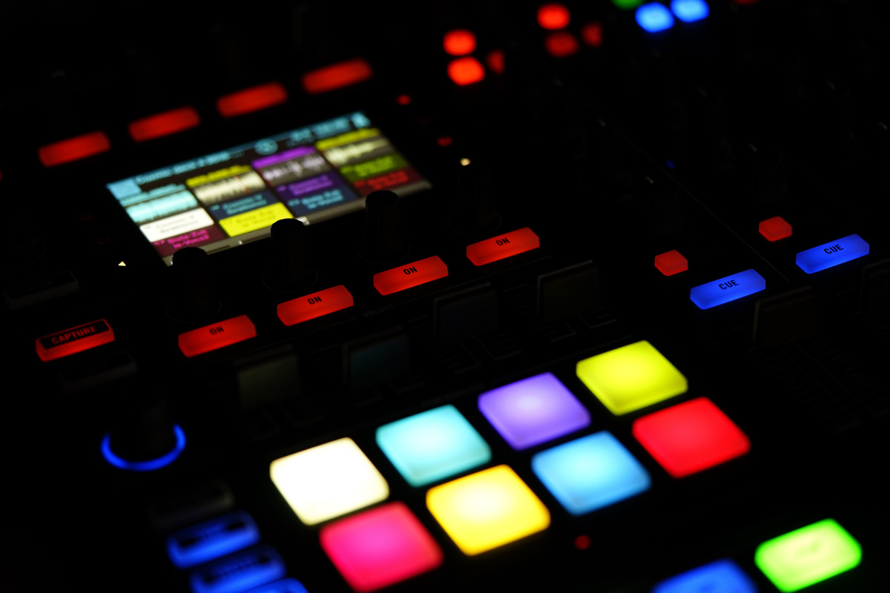

Go to the Mission 7 Remix Log and fill out the Pre-Remix preparation.



**Time for a project remix**

A remix can be:

* A new program created by adding new code to a program you already created
* You can combine parts of two or more programs in a remix
* Use a similar idea in a different way

**Creating a remix will let you:**

* Master the skills and concepts practiced in the mission
* Be creative
* Remember code from earlier programs and missions
* Work with your peers
* Design an original program and write the code all on your own

**Step #1: Review the mission**

* Review your programs from Mission 3 through 7
  + What do the programs do?
  + What skills were used or concepts learned?

**DO THIS:**

* Open your project from Mission 7 - Billboard
* Review what the program does
* Review the programming concepts and skills you learned
* 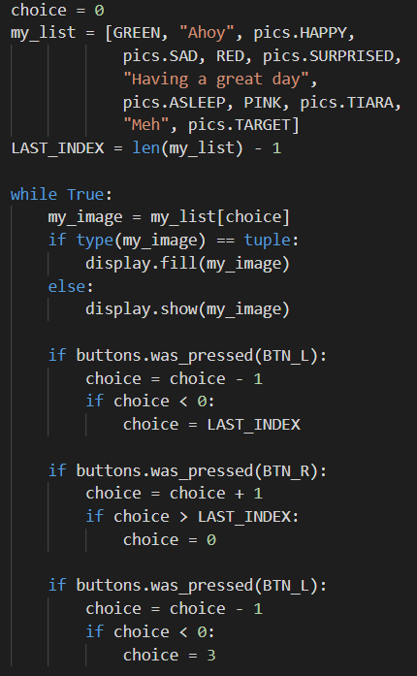Fill out the information in the remix log

**Step #2: Brainstorm ideas**

* Read through remix suggestions.
  + Eight ideas are on the next pages. You can use any of these ideas or come up with your own.
  + You can combine any parts of the suggestions into your spicy or extra spicy remix.
* Use your creativity to come up with your own idea for a project.
* Decide with your partner what project you will do.



**Mild Remix #1A**

Select a button (other than A or B) and add an if statement that will break out of the loop to stop the program.

[Video of Remix #1A](https://youtu.be/VWC3K6aOB18)



**Mild Remix #1B**

Create a list of 6 items (images, text or colors). Assign a value to choice when the button is pressed. Then display the image, text, or color from the list -- no scrolling needed.

[Video of Remix #1B](https://youtu.be/kgku3jY2Uvo)



**Medium Remix #2A**

Create a list of 6 items, like Mild #2. At the beginning, and after each item, clear the screen to black and print “Press a button”.

[Video of Remix #2A](https://youtu.be/l0u7qJhqMEc)



**Medium Remix #2B**

Add print statements that introduce the program, and add a loop that will “wait” until a button is pressed to begin. Also include a button that will break out of the loop and stop the program. Display an ending message.

[Video of Remix #2B](https://youtu.be/gyQjmYXHSS4)



**Medium Remix #2C**

Create two lists: one for images and one for sounds. Using the same “choice” variable, display an image and play a sound. You can use the audio sound files or tones.  
 Tone example: **audio.pitch(440, delay)**

[Video of Remix #2C (audio mp3)](https://youtu.be/l1dykwV0En8) / [Video of Remix #2C (tones)](https://youtu.be/Cs8V3gA5rfc)



**Medium Remix #2D**

Create a list of text strings with facts from math, science, history, etc. Scroll through and display the list of facts. You will need to sleep(), clear the display, and print a scroll message.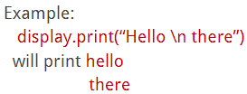

HINT: use \n in a string to print on a new line

[Video of Remix #2D](https://youtu.be/7NxYuRd0wzU)



**Spicy Remix #3**

Create 2 lists and use BTN_A and BTN_B to determine which list to display. Then use L and R to scroll through the lists. The lists can be anything that interests you, or facts from two different subjects.

[Video of Remix #3 (images, etc.)](https://youtu.be/GFumoZw_x4o) / [Video of Remix #3 (facts)](https://youtu.be/wwbfgGuTEYc)



**Extra Spicy Remix #4**

Add another list with colors. Use the list to light the pixels a different color for each corresponding item in the list. 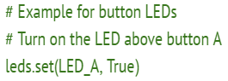

**Optional:** light up the red LED light above A or B when the button is pressed.

[Video of Remix #4](https://youtu.be/oFkkewX40sk) / [Video of Remix #4 with LEDs](https://youtu.be/Pi8CFDHY_NY)

**Step #2: Brainstorm ideas**

**DO THIS:**

* Decide with your partner what project you will do
* Fill out the information in the Mission 7 Remix Log for **Step #2**

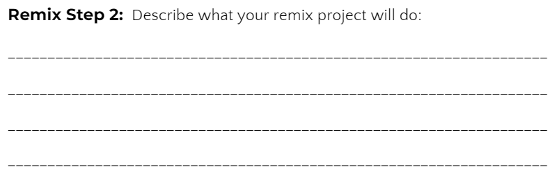

**Step #3: Make a plan**

Now that you have an idea for your remix, you need a plan.

* What variables will you need?
* What lists will you use, and what will be their items?
* What buttons will you program, and what will each button do?



**DO THIS:**

* Fill out the information in the Mission 7 Remix Log for **Step #3**

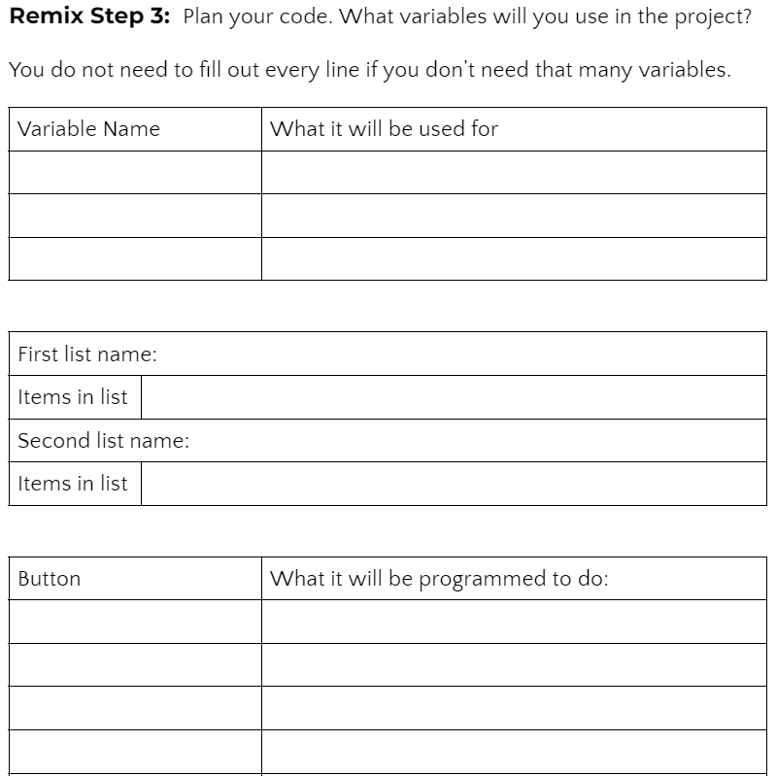

**Step #4: Code your project**

* **IMPORTANT:** In CodeSpace, go to the sandbox: 
* You can leave any program open, including **Billboard**, and use it as a guide



**DO THIS:**

* Start with a new file and give it a descriptive   
  name (**Remix7**)
* Import your modules
* Create your lists
* Define your variables
* Write your code, testing frequently

**Reminders!**

* Don’t try to write all the code at one time
* Mistakes happen, so find them early
* Type just a few lines of code and then run the program
* If there is an error, fix it before continuing
* Use the debugger and your other programs for help

**Step #5: Documentation**

You should always make your code readable and easy to follow.



**DO THIS:**

* + - * Add blank lines where needed to divide sections of code
      * Add a comment at the top with your name and the name of the program
      * Add a few more comments to sections of your code that explain what they do

**Step #5: Get feedback**

Getting feedback and reflecting on your code can help you make the program even better.



**DO THIS:**

* Show your code to another student
* Have him/her fill out the feedback form on your Mission 7 Remix Log
* Give yourself some feedback
* Is there something you want to change or improve or add?
* Fill out the feedback form on your Mission 7 Remix Log

**Modify your code to make your project even better**

**Congratulations!**

Now you have your own remix!   
Great job! Share your project with   
your friends.

By completing this remix you have:

* learned more about programming
* used skills and concepts from the missions
* been thinking!
* and problem solving
* and much more!
* 

**DO THIS:**

* Run at least three projects from other students
* Complete the Mission 7 Remix Log
* Don’t forget to clear your CodeX by running your **Clear** program